EXP NO – 14
PRODUCER–CONSUMER PROBLEM USING SYSTEMC

AIM
To implement and simulate the Producer–Consumer problem using SystemC.

PROGRAM
#include <systemc.h>
SC_MODULE(Producer)
{
sc_fifo_out<int> out;

SC_CTOR(Producer)
{
SC_THREAD(produce);
}

void produce()
{
for(int i = 1; i <= 5; i++)
{
cout << sc_time_stamp()
<< " : Producer Produced = "
<< i << endl;

out.write(i);

wait(2, SC_NS);
}
}
};

SC_MODULE(Consumer)
{
sc_fifo_in<int> in;

SC_CTOR(Consumer)
{
SC_THREAD(consume);
}

void consume()
{
int data;

for(int i = 1; i <= 5; i++)
{
in.read(data);

cout << sc_time_stamp()
<< " : Consumer Consumed = "
<< data << endl;

wait(3, SC_NS);
}
}
};

int sc_main(int argc, char* argv[])
{
sc_fifo<int> buffer(5);

Producer producer("Producer");
Consumer consumer("Consumer");

producer.out(buffer);
consumer.in(buffer);

sc_start();

return 0;
}

SIMULATION

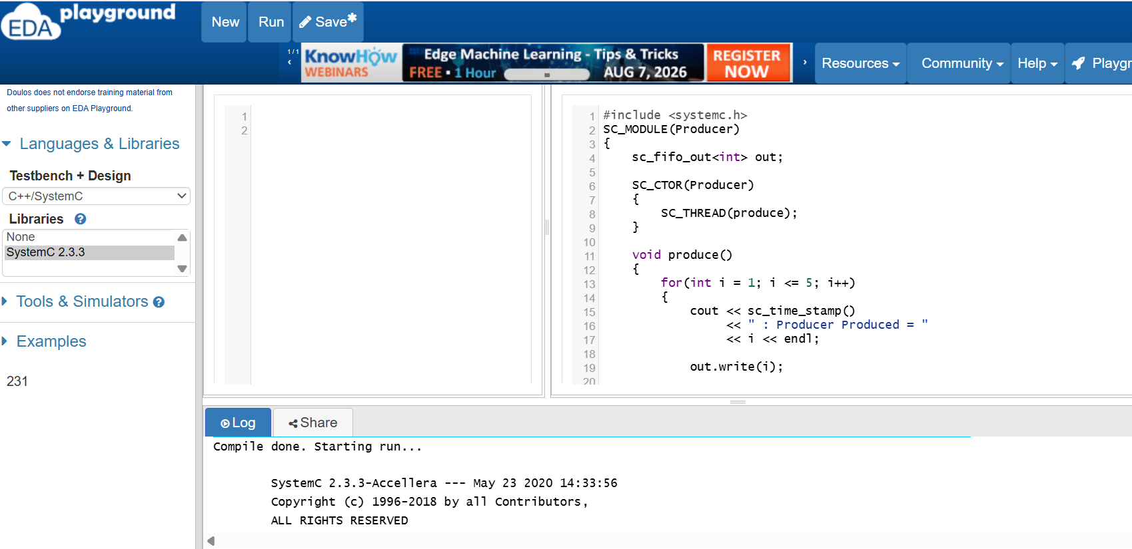

OUTPUT

